**Proof of Meetings:**

* **Daily Scrum**

[2020/05/04, 15:54:33] Phediso: So.... Uhmmm when is the meeting with Rylan

[2020/05/04, 16:09:01] Timmy: I’ll email him around 6

[2020/05/04, 16:09:12] Timmy: Then I’ll let you guys know

[2020/05/04, 16:18:18] Simphiwe Zulu: Alright

[2020/05/05, 14:49:13] ‎You changed the group description

[2020/05/05, 14:49:22] Timmy: Guys I’ve emailed Rylan

[2020/05/05, 14:49:53] Timmy: He said 12:00-12:30 is fine for him

[2020/05/05, 14:50:22] Razeen: Which day again?

[2020/05/05, 14:56:23] Timmy: Friday sorry 🤣🤒

[2020/05/05, 14:56:36] Timmy: I’ve sent invites to you guys

‎[2020/05/06, 15:09:44] Timmy: ‎audio omitted

[2020/05/06, 15:38:07] Simphiwe Zulu: I think this is a good idea 💡

[2020/05/06, 16:22:49] Timmy: Let me know what you guys think so we can execute on a clear plan moving forward

[2020/05/06, 16:38:24] Razeen: I’m cool w this 🙏🏼

Only concern I have, is if we’re shuffling tasks wouldn’t that hinder our progress a bit? Since we’ve all been on one certain type of task for so long

Agree with the documentation refinement tho

[2020/05/06, 16:43:09] Timmy: We could carry on with the people who’s doing their tasks then we just have like a meeting like on a Sunday where everyone shows the group what they’ve done and why they doing what they doing... just so everyone has a good foundation of all areas on the projects requirements

[2020/05/06, 17:50:47] Simphiwe Zulu: @27768590892

Have you managed to get access to the main Firebase project?

[2020/05/06, 18:20:29] Mikayla: I also agree with this. We could maybe have 2 people working on a task at a time to make sure everything is being done correctly but it will be hard for one of us to carry on from another task by ourselves cause we will have to figure out what's already been done

[2020/05/06, 21:57:45] Jesse Reid: Yes

[2020/05/06, 22:11:19] Simphiwe Zulu: Is it working?

[2020/05/07, 10:57:04] Jesse Reid: The website let's you log in but some of the functions don't work

[2020/05/07, 11:37:26] Jesse Reid: We meeting on meets?

[2020/05/07, 11:42:54] Timmy: Yeah

[2020/05/07, 12:02:30] Jesse Reid: U guys in the meeting?

[2020/05/07, 12:03:11] Razeen: It’s tomorrow?

[2020/05/07, 12:03:12] Mikayla: Are we having a meeting now?

[2020/05/07, 12:03:25] Jesse Reid: Oh wow

[2020/05/07, 12:03:33] Jesse Reid: Thought it was friday

[2020/05/07, 12:03:41] Jesse Reid: Sorry for the confusion

[2020/05/07, 12:04:00] Mikayla: Okay 😂

[2020/05/07, 12:05:59] Timmy: 🤣🤣🤣🤣🤣

[2020/05/07, 13:19:18] Simphiwe Zulu: Which functions aren't working?

[2020/05/07, 15:28:16] Jesse Reid: Create project and the project dropdown

[2020/05/07, 15:28:49] Jesse Reid: I made some adjustment that might have been deployed by now. I'll check if it's fixed soon

[2020/05/08, 11:08:55] Timmy: Don’t forget the meeting with Rylan today! Google Meet link in the invite!

[2020/05/08, 11:09:31] Razeen: I might have to leave slightly early for prayers but I’ll be there

[2020/05/08, 11:09:44] Timmy: Not a problem bru! 🙏🏼

[2020/05/08, 11:09:54] Timmy: Rylan will understand 🙏🏼

[2020/05/08, 11:58:34] Jesse Reid: Who's starting the meeting?

[2020/05/08, 11:59:05] Timmy: Just click the link

[2020/05/08, 11:59:08] Timmy: I’m on it now

[2020/05/08, 12:00:03] Jesse Reid: Where is the link?

[2020/05/08, 12:01:50] Timmy: It’s in the email link

[2020/05/08, 12:02:19] Timmy: Dude I sent the link on Tuesday

[2020/05/08, 12:02:42] Timmy: https://meet.google.com/trn-tvpe-tcn

[2020/05/08, 12:02:59] Timmy: Click this

[2020/05/08, 12:08:18] Jesse Reid: Tell him to join the site and make an account

[2020/05/08, 12:08:21] Jesse Reid: Then add him

[2020/05/08, 12:32:00] Timmy: Jesse come to discord

[2020/05/08, 12:32:08] Timmy: We in the meeting

[2020/05/08, 12:33:55] Timmy: @27658393602 @27823051038 ?

[2020/05/08, 12:33:59] Timmy: We waiting for you?

[2020/05/08, 12:34:25] Timmy: 🤣

[2020/05/08, 12:34:53] Phediso: I'm sorry. My laptop charger 😅. Its off

[2020/05/08, 12:42:15] Phediso: I'm sorry. Is the meeting done?

[2020/05/08, 12:42:33] Mikayla: No

[2020/05/08, 12:42:36] Razeen: Come to dischord

[2020/05/08, 12:43:20] Phediso: I'm there and I'm not seeing anyone except Jesse's last direct message

[2020/05/08, 12:44:21] Phediso: Nvm. I'm fine

[2020/05/08, 13:16:34] Razeen: What did you guys decide?

[2020/05/08, 13:22:39] Simphiwe Zulu: I'll be working on the back end with @27742073306

‎[2020/05/08, 13:25:13] Simphiwe Zulu: ‎image omitted

[2020/05/08, 13:25:46] Simphiwe Zulu: I'm just not sure how to go about assigning a user story to a member

[2020/05/08, 13:37:49] Timmy: We just add a collection for user stories and reference it by group ID... and make it that every developer and project owner can add a user story for that project

[2020/05/08, 13:39:31] Simphiwe Zulu: The group ID would be the project_ID in this case

[2020/05/08, 13:39:37] Timmy: Yeah

[2020/05/08, 13:39:44] Simphiwe Zulu: But yeah. That's what we're doing

[2020/05/08, 13:41:23] Simphiwe Zulu: I'll write out the sprints one which will be similar to this. Each sprint document will have a subcollection for user stories.

[2020/05/08, 13:42:22] Timmy: Yeah this is the format Rylan wants 👌🏼👌🏼

[2020/05/08, 15:15:25] Razeen: Have we decided on the roles?

[2020/05/08, 15:55:48] Timmy: I think Rylan is happy with project owner and developer

[2020/05/11, 10:33:56] Jesse Reid: Are we having a meeting today?

[2020/05/11, 11:16:51] Timmy: I mean I think we just need to carry on with the tasks we gave ourselves from Friday’s meeting

[2020/05/11, 11:16:59] Timmy: What do you guys think?

[2020/05/11, 11:30:05] Timmy: Just so everyone’s clear... reply on a message if you involved in that area of the project

[2020/05/11, 11:30:09] Timmy: GUI

[2020/05/11, 11:30:15] Timmy: Backend

[2020/05/11, 11:30:30] Timmy: Testing & Coverage

[2020/05/11, 11:30:42] Timmy: Documentation

[2020/05/11, 11:30:45] Razeen: Here

[2020/05/11, 11:31:12] Timmy: I’m here

[2020/05/11, 11:37:47] Razeen: Don’t mind crossing over into documentation if I need to do something

[2020/05/11, 12:14:38] Mikayla: Here

[2020/05/11, 12:14:40] Mikayla: Here

[2020/05/11, 12:19:57] Jesse Reid: Here

[2020/05/11, 12:20:14] Simphiwe Zulu: Here 🙋‍♂

[2020/05/11, 12:32:42] Phediso: Me. I thought we said we'd assign these on taiga. Everyone will just choose what they wanted 😅

[2020/05/11, 12:44:38] Timmy: I’m still busy with that one 👌🏼

[2020/05/12, 10:51:09] Timmy: Okay so I’ve updated taiga with user stories from rylan... if there’s any missing for this sprint please add that user story... okay so you guys can now just assign yourself tasks related to the user story of your choice

[2020/05/12, 11:00:39] Timmy: So I’m layman’s terms... if you part of GUI... then you assign yourself a task from a user story and say “I’m doing the GUI implement of this user story”... etc etc

[2020/05/12, 11:00:47] Timmy: I hope this makes sense 🤣

[2020/05/12, 11:57:26] Jesse Reid: Simphiwe, I deleted the users in the database but I can still log in. Do you have any idea why this is happening? Can everyone go to sd-manager.web.app and try log in with users you created

[2020/05/12, 12:07:55] Timmy: Yeah bru I’m logged in

[2020/05/12, 12:13:11] Timmy: Nvm this was for your deployment Jesse... Simphiwe’s one doesn’t allow me to log in

[2020/05/12, 12:46:57] Simphiwe Zulu: I'm not sure

[2020/05/13, 00:29:33] Simphiwe Zulu: You deleted the user documents but didn't delete users from the Firebase Auth feature which handles user accounts. This is why you can still log into your accounts

[2020/05/13, 00:33:34] Jesse Reid: Oh

[2020/05/13, 00:34:11] Simphiwe Zulu: Why did you delete everything in the database?

[2020/05/13, 00:36:25] Jesse Reid: Cause the project and user documents need to contain more information so older projects and users would have to be manually changed

[2020/05/13, 00:36:41] Jesse Reid: Edited

[2020/05/13, 00:37:16] Jesse Reid: Quicker to just make new users and projects for the upcoming tests

[2020/05/13, 00:37:26] Jesse Reid: When we start adding stuff

[2020/05/13, 00:41:27] Simphiwe Zulu: Alright

[2020/05/13, 00:42:05] Simphiwe Zulu: I'm taking a look at your code to see your database structure for saving user information

[2020/05/13, 00:47:14] Jesse Reid: I need to add last name and first name

[2020/05/13, 00:48:52] Simphiwe Zulu: Alright

[2020/05/13, 00:49:25] Simphiwe Zulu: I think we should add a field that asks for the github link to the repository when creating a new project

[2020/05/13, 00:50:00] Simphiwe Zulu: That way we can save it with the project information in the database

[2020/05/13, 00:50:09] Jesse Reid: Yeah

[2020/05/13, 00:50:49] Jesse Reid: Do you think we should bother with server side functions?

[2020/05/13, 00:51:26] Jesse Reid: Is their main purpose extra security?

[2020/05/13, 00:51:47] Simphiwe Zulu: Yeah

[2020/05/13, 00:52:26] Simphiwe Zulu: It's for extra security

[2020/05/13, 00:52:34] Jesse Reid: Do they take a long time to deploy? If so, would that be a problem for testing purposes?

[2020/05/13, 00:54:49] Simphiwe Zulu: I'm running into problems with testing since they take long to run 🙃. The unit tests only give the tests 2 seconds to run and they appear to take longer.

[2020/05/13, 00:55:52] Jesse Reid: Should we just use local js functions since Rylan hasn't mentioned security once

[2020/05/13, 00:56:38] Jesse Reid: Plus our database api is hidden, is that security enough?

[2020/05/13, 00:59:01] Simphiwe Zulu: Fair point but the way you're saving the data needs to change. This code doesn't look like it will work when multiple users use the platform.

[2020/05/13, 01:05:14] Jesse Reid: Do what needs to be done

[2020/05/13, 01:06:16] Jesse Reid: By the way I'm saving data do you mean my document structure or the way I save it to the database?

[2020/05/13, 01:06:27] Simphiwe Zulu: Yeah

[2020/05/13, 01:07:08] Jesse Reid: Which one?

[2020/05/13, 01:07:12] Simphiwe Zulu: The documents don't seem to have ids and no way to trace it back to the user

[2020/05/13, 01:07:13] Jesse Reid: Or is it both?

[2020/05/13, 01:07:27] Simphiwe Zulu: Both 😅

[2020/05/13, 01:08:00] Jesse Reid: What can we change?

[2020/05/13, 01:08:50] Simphiwe Zulu: Just the referencing you use for the documents

[2020/05/13, 01:09:17] Jesse Reid: What do you mean?

[2020/05/13, 01:09:33] Jesse Reid: How I query?

[2020/05/13, 01:11:38] Simphiwe Zulu: Yeah

[2020/05/13, 01:13:04] Timmy: That’s what Rylan said we must do bru🙏🏼

[2020/05/13, 01:13:11] Jesse Reid: Can you send a picture of where it's a problem pls

‎[2020/05/13, 01:15:03] Simphiwe Zulu: ‎audio omitted

[2020/05/13, 01:17:32] Jesse Reid: But doesn't set create a new document in the collection with a unique ID?

‎[2020/05/13, 01:18:47] Jesse Reid: ‎image omitted

[2020/05/13, 01:20:26] Jesse Reid: I used newProjectRef as a link to the collection and shouldn't set make a new document even if everything saved in the document is identical to another project

‎[2020/05/13, 01:22:19] Simphiwe Zulu: ‎image omitted

‎[2020/05/13, 01:22:51] Simphiwe Zulu: ‎image omitted

[2020/05/13, 01:24:18] Jesse Reid: I see

[2020/05/13, 01:24:32] Jesse Reid: So we must change the sets to adds

[2020/05/13, 01:25:20] Jesse Reid: How many other problems have you found?

[2020/05/13, 01:25:34] Simphiwe Zulu: Yeah

[2020/05/13, 01:26:21] Simphiwe Zulu: I'm still looking

[2020/05/13, 01:26:26] Jesse Reid: Cool

[2020/05/13, 02:08:22] Simphiwe Zulu: @27768590892

What's localStorage?

[2020/05/13, 09:03:39] Jesse Reid: Saves data on the pc under a name you give it to be used later by calling the name you gave it

[2020/05/13, 14:04:28] Simphiwe Zulu: Alright

[2020/05/13, 22:26:55] Jesse Reid: You find any more problems?

[2020/05/13, 23:31:43] Simphiwe Zulu: Nah

[2020/05/14, 16:24:38] Jesse Reid: Sprint retrospective is this coming Monday or next Monday?

[2020/05/14, 16:25:34] Razeen: Following Monday, the 25th

[2020/05/14, 16:27:41] Jesse Reid: Cool

[2020/05/15, 11:58:53] Mikayla: Are we meeting now?

[2020/05/15, 12:05:35] Phediso: There's a meeting?

[2020/05/15, 12:06:02] Mikayla: Well it's Friday 🙈 I thought we meet at 12 on Friday

[2020/05/15, 12:08:04] Phediso: Is there one??

[2020/05/15, 12:09:58] Mikayla: Just me 😂😂😂

‎[2020/05/15, 12:12:52] Phediso: ‎GIF omitted

[2020/05/15, 13:41:23] Simphiwe Zulu: We can just update each other on what we've done so far

[2020/05/15, 13:43:11] Simphiwe Zulu: I haven't started with the new features yet but I've been working on the current features and got them to create new documents every time a project and/or a user is created

[2020/05/16, 02:38:29] Simphiwe Zulu: I managed to get most of the current features to work. I just need to write security rules to allow the other feature to work.

[2020/05/18, 11:28:37] Timmy: Do you guys want to discuss what we still need to do over WhatsApp instead of video call🤒

[2020/05/18, 11:28:40] Timmy: ?**

[2020/05/18, 11:29:00] Timmy: For our meetings?

[2020/05/18, 11:49:27] Razeen: We should rather have video calls about it

[2020/05/18, 11:51:57] Timmy: Shot we’ll use discord then

[2020/05/18, 12:07:49] Jesse Reid: We meeting now?

[2020/05/18, 12:33:48] Timmy: 1pm boss

[2020/05/18, 13:23:50] Timmy: Phediso are you still busy with the GUI for the user story’s rylan gave us and Simphiwe you busy with the backend part? Jesse and I are busy finishing up the testing and Mikayla and Razeen is busy with GUI and Docu... basically in the meeting we discussed we must just carry on to get this stuff done and if anyone needs help just shout out! 🎉🎉 We planning to meet on Friday and then Sunday like we did before the sprint retrospective

[2020/05/18, 13:24:28] Timmy: Guys should we meet with rylan again? Like I don’t know what else to talk to him about?

[2020/05/18, 13:26:10] Simphiwe Zulu: I was busy trying to get the current features that we have working for the current database. I just have to merge it with the master branch.

[2020/05/18, 13:26:55] Timmy: Lekker bru 🎉👍🏼

[2020/05/18, 13:28:12] Phediso: Yes I am... Also i am busy with the diagram. Actually I'm done. I'll send it through for y'all to tell me if it's correct

[2020/05/18, 13:29:36] Mikayla: I think we only have to meet with him again after this sprint

[2020/05/18, 13:30:28] Razeen: I’m going to think of a proper GUI layout tonight for the creating sprints and user stories and all that, and then I’ll show you those things and then you can just tell me what to remove or add and then add your functionality to it

[2020/05/18, 13:31:41] Simphiwe Zulu: Sweet 👌

[2020/05/18, 19:42:49] Mikayla: Hi guys

So I took a look at those videos posted on the diagrams and we are doing the right thing. I think we just need to elaborate more in the diagrams so I'll edit the diagrams I've already done to include more info and also separate them. @27835333588 @27823051038 you guys can do the same. I think we should also check that our diagrams are matching because our plans have changed a bit.

[2020/05/18, 23:33:49] Razeen: I’ll check mine out and see what else I can improve 🙏🏼

[2020/05/20, 14:58:35] Razeen: Are we meeting for SD any time soon

[2020/05/20, 14:59:31] Timmy: I think we need to meet Friday

[2020/05/20, 14:59:47] Timmy: Is 12:00-13:00 fine?

[2020/05/20, 15:00:03] Razeen: Can we do 13:00-14:00

[2020/05/20, 15:00:14] Timmy: That is also fine 🙏🏼

[2020/05/20, 15:03:36] Razeen: @27744207635 what are the data attributes for the User Stories? The description and the points?

[2020/05/20, 15:04:51] Razeen: Or title, name, status and points?

[2020/05/20, 15:26:59] Simphiwe Zulu: Title is the name of the user story. There should be a select element for the status of the user story. There should also be points. There should be a text area for the description of the user story as well as the acceptance criteria.

[2020/05/20, 15:37:20] Razeen: Okay sweet I’ll get on that ASAP 🙏🏼

‎[2020/05/21, 01:59:58] Razeen: ‎audio omitted

[2020/05/21, 08:14:31] Timmy: Lovely stuff razeen! 🙏🏼

[2020/05/21, 16:26:41] Timmy: Guys is it possible to reschedule our meeting for 12-1 tomorrow? Razeen, Mikayla and I just had a bit of a situation for the CGV so we can only have that CGV meeting from 13:30 onwards

[2020/05/21, 18:57:54] Simphiwe Zulu: I got a check up with the doctor tomorrow so I won't be able to attend at that time

[2020/05/21, 19:24:35] Timmy: 11-12?

[2020/05/21, 19:36:44] Simphiwe Zulu: I'm not sure when I'll be available actually

[2020/05/21, 20:03:25] Mikayla: We can even do it in the evening? Or maybe Saturday morning just to make sure we have time for small changes before our Sunday meeting where we can check against the rubric

[2020/05/21, 20:09:38] Phediso: Evening will be fine

[2020/05/21, 20:26:37] Razeen: I’m good with this

[2020/05/21, 20:26:58] Timmy: Evening is also lekker

[2020/05/22, 14:40:03] Mikayla: So what time tonight?

[2020/05/22, 14:41:50] Razeen: Just can’t do between 7 and 8 but everything else is fine w me

[2020/05/22, 14:42:43] Timmy: What about 8? Or maybe 6?

[2020/05/22, 14:43:21] Razeen: I’m fine with that

[2020/05/22, 14:44:00] Mikayla: I'm fine with either

[2020/05/22, 14:45:50] Timmy: Let’s do 8 then

[2020/05/22, 20:02:07] Mikayla: Sorry guys I'm going to be a bit late

[2020/05/22, 20:07:18] Razeen: Just give me 10 minutes guys, my lights went again, switching my generator on

[2020/05/22, 20:25:07] Phediso: My internet connection is really flunking on me

‎[2020/05/22, 20:25:29] Phediso: ‎image omitted

[2020/05/22, 20:29:52] Phediso: I'm sorry. It keeps saying RTC Connecting

[2020/05/22, 20:33:55] Mikayla: Sorry guys I'm having a problem with connectivity

[2020/05/22, 20:33:56] Mikayla: I don't even know when this message is gonna sent 🙈

[2020/05/22, 20:34:59] Razeen: @27823051038 what exactly do you need help with?

‎[2020/05/22, 20:37:57] Mikayla: ‎audio omitted

‎[2020/05/22, 20:39:04] Phediso: ‎audio omitted

‎[2020/05/22, 20:51:34] Phediso: ‎audio omitted

[2020/05/22, 21:08:29] Mikayla: Guys I can't hear much on the call but it's on my side. It's my connection 🙈 please will you update me on what you talk about

[2020/05/22, 21:11:41] Timmy: Alright guys is there anything you guys still need to finish by Sunday?

‎[2020/05/22, 21:12:28] Timmy: ‎image omitted

[2020/05/22, 21:12:45] Timmy: #25 is for Jesse and I for example

[2020/05/22, 21:13:15] Mikayla: #28, #29

[2020/05/22, 21:14:07] Razeen: #26,#30,#29,#25 (GUI side)

[2020/05/22, 21:14:32] ‎You changed this group's icon

‎[2020/05/22, 21:30:53] Simphiwe Zulu: ‎audio omitted

[2020/05/22, 21:32:51] Phediso: Oh like in your project, you have a tab that takes you to your github repository. Thank you. I'm working on that now

[2020/05/23, 12:07:29] Jesse Reid: Simphiwe, pls create a sprint doc with a user story in the database so I can see the structure

[2020/05/23, 15:28:36] Simphiwe Zulu: I'll do it soon

[2020/05/23, 16:30:21] Simphiwe Zulu: Check it out in the projects collection. I named it example_project

[2020/05/23, 16:35:47] Mikayla: I've uploaded the create user pop-up to github on my branch

[2020/05/23, 16:36:19] Mikayla: I also wanted to know if we are assigning user stories and task to members of a group

[2020/05/23, 16:36:39] Mikayla: I didn't add that and I only thought of it now

[2020/05/23, 16:36:56] Razeen: I think we’re just displaying it for now

[2020/05/23, 16:37:29] Mikayla: Okay cool

[2020/05/24, 01:55:53] Simphiwe Zulu: @27835333588 may you please sync your repository with the online one and make the following:

- a "Create New Sprint" button with modal in the projects pages. I will create a list of existing sprints in a projects database and each sprint will direct the user to SprintPage.html

- CSS style for a class name 'sprint_btn'. I will use this class when creating new sprint buttons

[2020/05/24, 01:58:16] Razeen: Sweet, I’ll get cracking on it in the morning

[2020/05/24, 01:58:56] Razeen: If I sync mine with the online one it won’t make any changes to other SD manager files right, and would just add the files I created. Just wanna make sure

[2020/05/24, 02:01:09] Simphiwe Zulu: Well you should only see changes where I've made them. In this case, I pulled the master repository to get the other files in the same folder and edited a few. It shouldn't make any other modifications other than that

[2020/05/24, 02:05:31] Razeen: Ayt cool I’ll check it out

[2020/05/24, 02:27:13] Simphiwe Zulu: May you please create style the content of SprintPage.html. Create a class for user story cards which will populate the page. They'll be dynamically populated the same way that the drop downs 🙏

[2020/05/24, 02:31:17] Razeen: Cards? I haven’t tried dynamically creating materialize objects but I’ll try

[2020/05/24, 02:36:15] Simphiwe Zulu: https://getbootstrap.com/docs/4.0/components/card/

[2020/05/24, 02:36:33] Simphiwe Zulu: Something like this 😅🙏

[2020/05/24, 02:42:15] Razeen: Sweet I’ll give this a look

[2020/05/24, 02:47:28] Razeen: Yeah I know the cards 😂 I’m just saying I haven’t done it dynamically before but I’ll check it out 🙏🏼 cards sound like a much more user friendly idea

[2020/05/24, 10:22:44] Mikayla: Are we meeting today? Or just tomorrow before the retrospective

[2020/05/24, 10:54:29] Timmy: I think it will important we meet this afternoon and just before the retro meeting tomorrow

[2020/05/24, 10:54:55] Timmy: What do the rest of you guys think?

[2020/05/24, 11:12:00] Timmy: We can meet on google meet to test that everyone’s mic is working for the retrospective

[2020/05/24, 11:23:46] Mikayla: I agree

[2020/05/24, 12:19:48] Razeen: @27744207635 should I add this to the project developer and project owner pages?

[2020/05/24, 12:27:50] Razeen: I agree.

What time are we doing this?

[2020/05/24, 12:28:11] Timmy: 4?

[2020/05/24, 12:28:24] Razeen: That’s good w me 🙏🏼

[2020/05/24, 12:59:52] Simphiwe Zulu: Yes. Both

[2020/05/24, 14:45:35] Simphiwe Zulu: Does Materialize have calendars?

[2020/05/24, 14:45:36] Simphiwe Zulu: We can use them for added the sprint dates

[2020/05/24, 15:45:02] Razeen: I think it does yeah

[2020/05/24, 15:50:36] Simphiwe Zulu: How do I apply one?

[2020/05/24, 15:52:27] Razeen: https://youtu.be/GxoTvqt5JLo

[2020/05/24, 15:52:48] Razeen: I haven’t tried to implement it before but this might be helpful

[2020/05/24, 15:53:14] Simphiwe Zulu: Thanks

[2020/05/24, 15:55:08] Timmy: Guys please join the google meet link our tutor made for us

[2020/05/24, 15:55:12] Timmy: For the meeting today

[2020/05/24, 15:55:23] Timmy: We need to all contribute in tomorrow’s meeting

[2020/05/24, 16:02:23] Phediso: Someone let me in

‎[2020/05/24, 16:27:25] Simphiwe Zulu: ‎image omitted

[2020/05/24, 16:53:01] Mikayla: Sorry I'm having a problem with connectivity

[2020/05/24, 16:53:13] Mikayla: If you're still talking to me 🙈

[2020/05/24, 16:54:03] Timmy: Okay mikayla

[2020/05/24, 17:58:39] Jesse Reid: Committed to my branch simphiwe

[2020/05/24, 18:29:01] Simphiwe Zulu: Awesome

[2020/05/24, 21:15:42] Simphiwe Zulu: @27768590892 did you upload the whole of your public folder into the public folder on your repository?

I see a public folder in the public folder and I'm not sure which one is the one I should edit. May you please sort this out so I can pull from your repository 🙏

‎[2020/05/25, 10:14:23] Timmy: ‎image omitted

[2020/05/25, 10:14:32] Timmy: @27744207635

[2020/05/25, 11:44:13] Timmy: May everyone who took notes with Rylan’s meeting send pics of it

[2020/05/25, 11:44:19] Timmy: Please 🤣

[2020/05/25, 11:44:36] Simphiwe Zulu: I didn't run the emulator

* **Sprint Planning**

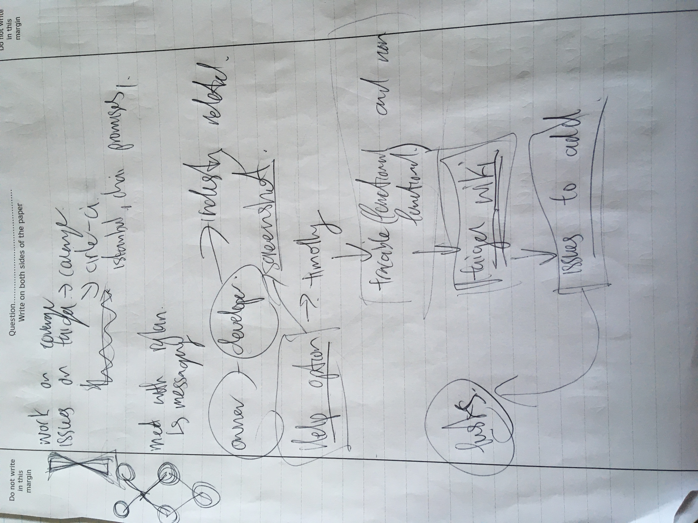

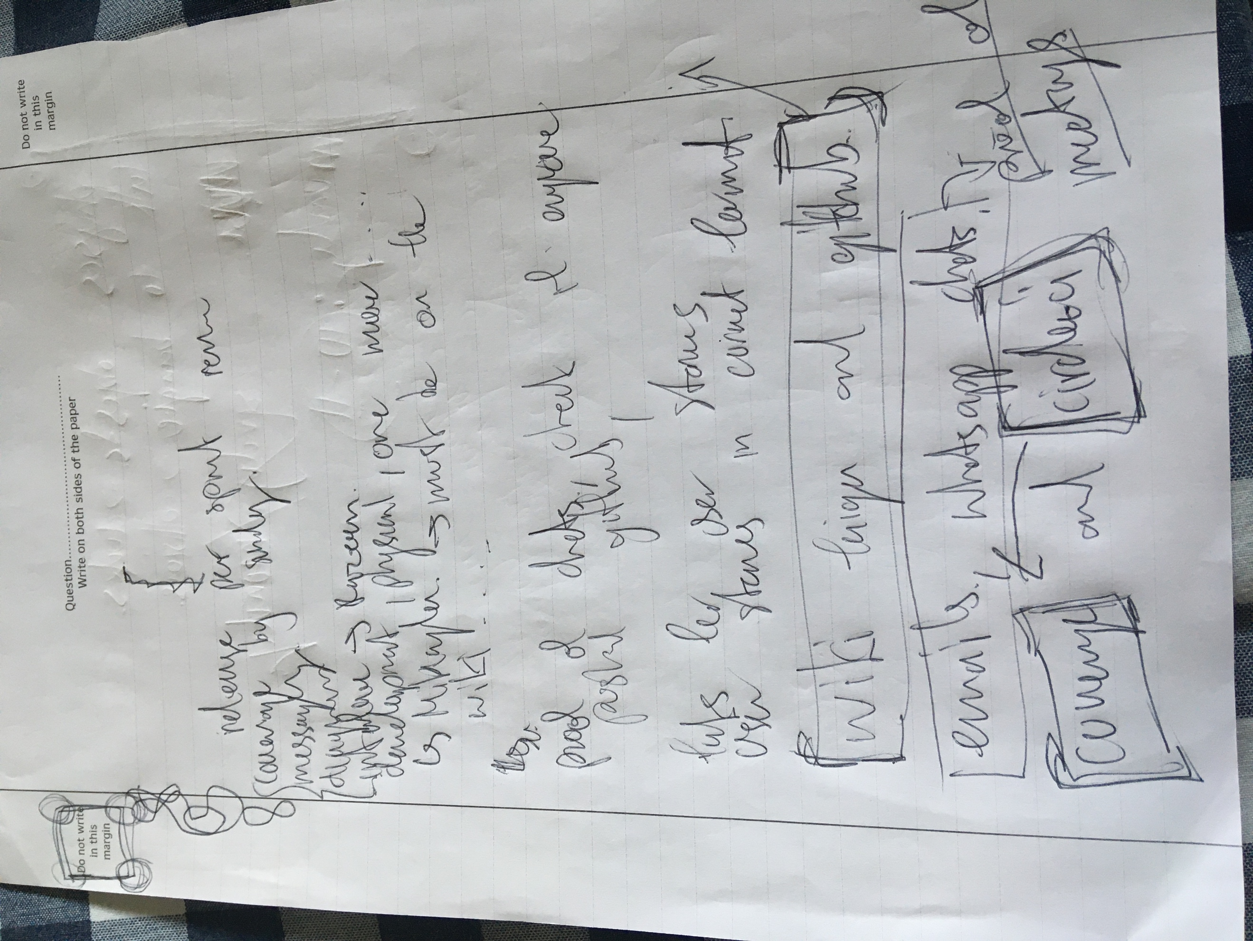

* **Sprint Review**

